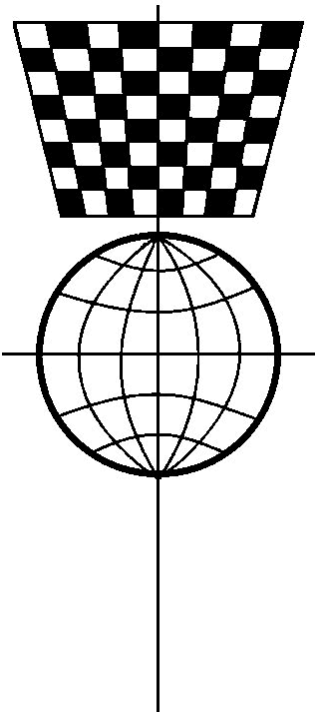
2026
Scottish Correspondence Chess Association
Tournament Entry and Magazine Subscription

This form is for entry to SCCA tournaments.
For membership of the SCCA please use the membership form.

Remember that all membership classes, except Associate, automatically include a
subscription to the quarterly e-magazine which you can download from the SCCA website.
Please note that printed copies of the magazine were discontinued from 2024.
.

Name

Section 1: Your Playing Requirements

A Playing Mode
Please tick all the methods you are willing and able to play. |  | € Postal |  | € Email |  | € Webserver

B Introductory Games
If you haven’t played here before, would you like 1 or more introductory opponents? |  |  |  |  | (yes/no)
If you are an experienced player, would you be willing to play introductory games against new or inexperienced members? |  |  |  |  | (yes/no) |  | (how many?)
C Championship Events |  |  | How many? |  | Fee |  |  | Total
Final  Duration 2 years; 1 section; 1 game/opponent. |  |  | (1 max) |  | One free entry to any event.  Additional entries to Premier and Open cost £3:

Premier
Duration 1 year; 1+ sections; 1 game/opponent.

Open
Duration 1 year; 1+ sections; 2 games/opponent.
D Other Events |  |  | How many? |  | Fee
Challengers  Entry at any time; any number of matches (2 games per match)  (minimum of 4 matches required for a medal) |  |  | (matches) |  | All individual events are free to patron, life and annual members.  Teams may be entered by organisers for a fee of £10. No additional fees are required for individual team members.
International Friendly Matches  Usually 3+ per year; 2 games/opponent. |  |  | (matches)
International Team Events  Do you wish to represent Scotland if selected? |  |  | (yes/no)
Team League Player  If you are not currently a team member but would like to play in the League, please indicate here. |  |  | (yes/no)

Section 2: Extras and Total Payable
 |  |  | Fee |  |  |  |  | Total
Printed Magazine  Not available from 2004 onwards. |  |  | N/A |  |  |  |  | N/A
Donations  We usually just cover our costs, so any extra donations help us to develop new services for our members. |  |  | £any
Grand Total  Please total up all the fees due – remember to multiply the rate by the number of sections you have entered where applicable. |  |  |  |  |  |  |  | £
Please make cheques and postal orders payable to the Scottish Correspondence Chess Association.
To pay by bank transfer please refer to Scottish Correspondence Chess Association,
Sort Code 80-91-28, Account Number 00248355.
Please return your entry form and payment to Benjamin Major
Email: membership@scottishcca.co.uk or
Postal: 39 Hillhead Rd, Kirkintilloch, Glasgow, G66 2HT.
Tel: 07961 238 123

Note that to play in the Scottish Championship Final and/or represent Scotland in ICCF Team events, you need to be registered as Scottish. Non-Scots resident in Scotland are able to play in our Premier, Open and Challengers events, plus International Friendly Matches. Scots and non-Scots resident anywhere are able to play in our Team Leagues which are run as ICCF International Events. See also: at: www.scottishcca.co.uk/policies

